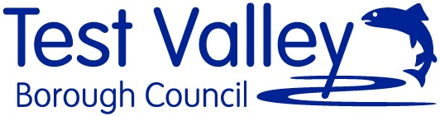 | 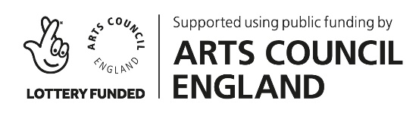
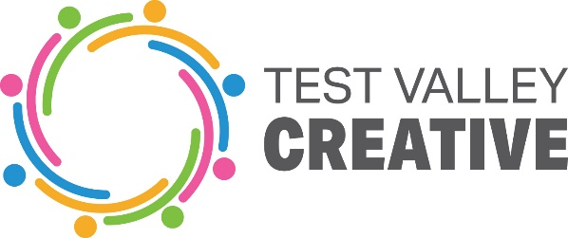

Project: Library Connections
Free: £3,000
Deadline: Monday 10 January 2021

Vision
Test Valley Borough Council in Partnership with Hampshire County Council Library Service wish to commission socially engaged artists to collaborate on a project for Andover and Romsey.
The project will explore how artists can support the library service to reach identified isolated communities through bespoke designed creative arts practice, workshops and events.
We are interested to receive collaborative applications from artists combing two arts practices.
Aims
- To engage people who are isolated, in creative arts activities and workshops.
- To create a mix of outreach activities and library based activities exploring the different ways people can use and enjoy their libraries.
- To explore the themes of how the lockdown has affected how we engage with reading.
- To allow a space for artists to collaborate in designing participatory arts projects for specific groups
Location
The projects are focused on activities at both Libraries in the Test Valley including Andover and Romsey. It will also include outreach activities relevant to the design of the project.
The aim is to work with people from some of the socially deprived areas in our borough who have been affected by the lockdown and in terms of social isolation. These areas will be as follows, please click titles for ward profiles.
The Harrow Way Ward, Andover
Romsey Abbey Ward, Romsey
Outcomes
- Outreach and Library based creative activities
- Activities designed to engage people in new ways
- Workshops and events at Libraries, physical or online.
- An evaluative project report explaining the understanding of how the arts can support engagement with library services and how we could develop this further.
Timeline
We anticipate the project will take place in December/January and run for a month having an activity each week with a final outcome.
Fee
£3,000
This fee is based on £250 per day and is inclusive of project planning and time toward evaluations.
We expect that at least 8 days are focused on creative delivery.
How to Apply
Your submission should include:
- An outline proposal including suggestions of activities you envisage (not a full project plan at this stage) You should include details about your links to the Test Valley
- Proposed Budget
- Timeline
- Two referees who can be approached
- Examples of previous work of each artist (2 pages max) Please include an artist/organisation’s statement explaining how you will collaborate your work and/or artforms and what you hope to achieve by doing so
- Artists will be required to hold a DBS certificate and Public Liability Insurances.

Submissions will be shortlisted by a commissioning panel of TVBC and HCC members of staff, shortlisted artists/organisations will be invited to give a presentation of their proposal on Monday 24 January.

This should be sent to: Faye Perkins, Arts Officer, Test Valley Borough Council
by Monday 10 January 2022
Email: fperkins@testvalley.gov.uk

