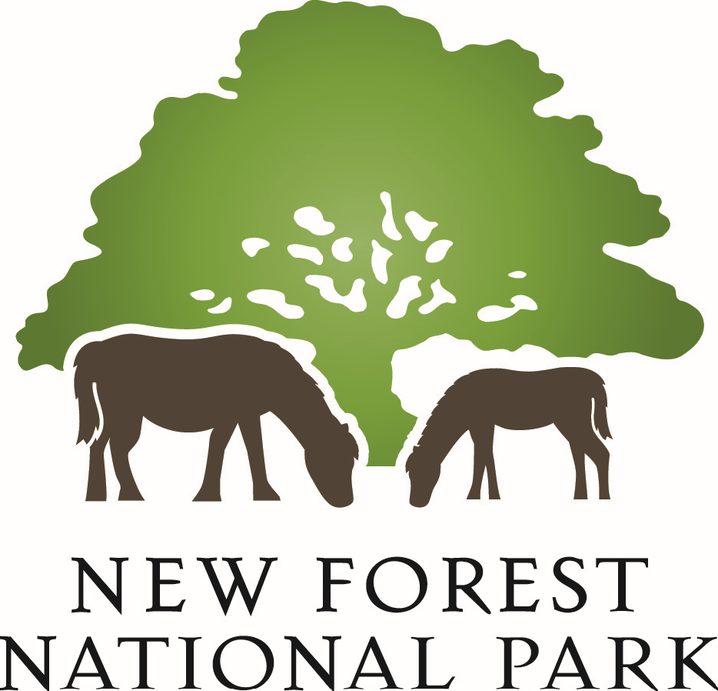
Wellow Neighbourhood
Development Plan
Regulation 16 Consultation Response Form

Please return your completed response form to Test Valley Borough Council via either:
- E-mail: Neighbourhoodplanning@testvalley.gov.uk or
- Post: Planning Policy, Beech Hurst, Weyhill Road, Andover, SP10 3AJ.

The consultation ends at Noon on Monday 18 December 2023.

Please review the Data Protection section, and sign and date at the end of this response form.

Guidance Note:
This response form has two parts:
Part A – Contact Details and Future Notification
Please provide your personal contact details. If an agent is appointed to represent you, then they would need to provide their full contact details in addition to your Title, Name and Organisation (if applicable). This information is required to enable the Independent Examiner to contact you for further information if required during the examination of the Neighbourhood Plan.
Consultees can request to be notified once Test Valley Borough Council and the New Forest National Park Authority have decided to ‘make’ the Wellow Neighbourhood Development Plan, following the Independent Examination and referendum. This decision is the final statutory stage in adopting a Neighbourhood Plan. Please indicate whether or not you wish to be notified.

Part B – Your representation(s)
If you are responding using this form, please use a separate Part B form for each different part of the Plan that you respond to (for example, one form per document or per policy).

Please use the table to set out which document and which part of that document your comments relate to. If your comment is on a specific element please set this out in the table. Your comments should then be written in the box – please state if you have included any attachments as part of your comments.

Part A – Contact Details and Future Notification
Contact Details
 | 1. Personal Details (or Client Details if applicable)** | 2. Agent’s Details (if applicable)
Title*
First name*
Last name*
Job title
(where relevant)
Organisation
(where relevant)
Address*
Postcode*
Telephone Number
Email Address
*Please note: these sections must be completed.
**If an agent is appointed, please provide the client’s Title, Name and Organisation.
Future Notification
Do you wish to be notified of the planning authorities’ decision to ‘make’ the Wellow Neighbourhood Development Plan? (Please tick):
Yes: |  | No:

Part B – Representation

Please use a separate Part B form for each document/paragraph/policy that you are making representations about.

To which document does this representation relate?

(please tick only one document per Response Form and indicate the section / policy number / paragraph number to which your comments relate to)

Consultation Document | Tick | Section/ Policy/ Paragraph
Wellow Neighbourhood Plan
Wellow Design Code
Basic Conditions Statement
Consultation Statement
Designated Area Map

Please write your comments in this box: (Please attach an additional page to your response if required)

Data Protection

Data Protection: The comments you submit will be used to inform the Neighbourhood Plan process and will be held for the lifetime of the Neighbourhood Plan. Please note that your comments will not be treated as confidential and will be made available for public inspection. However, contact details will not be made public and will not be passed to external parties, apart from the Examiner, without permission. For further information on how we use your personal data please visit http://www.testvalley.gov.uk/gdpr
Please tick the box to confirm you are happy for your comments to be used in this way

Signed …………………………………… Date …………………………

Please return the completed forms by:  Email: Neighbourhoodplanning@testvalley.gov.uk  Post: Neighbourhood Planning, Test Valley Borough Council, Beech Hurst, Weyhill Road, Andover, SP10 3AJ. | For more information:  Telephone: 01264 368150  Website: www.testvalley.gov.uk.

If you require any assistance in completing this form or require further information, please contact the Neighbourhood Planning team.

