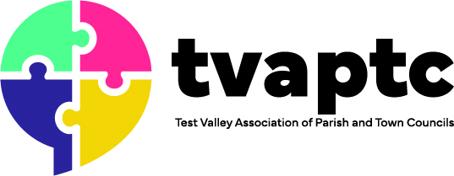
Save the Date

Test Valley Association of Parish and Town Councils and Test Valley Borough Council Joint Conference
Saturday 21 September
King’s Somborne Village Hall
9:30 – 12:30

The conference is open to any parish or town councillors or clerks
There will be tea, coffee and breakfast sandwiches from 9.30am with a networking marketplace.
Further details of workshops will be circulated shortly but if you would like to note your attendance at the joint Annual Conference then please contact Rebecca D’Alcorn at RDalcorn@testvalley.gov.uk

