Equality information
March 2018

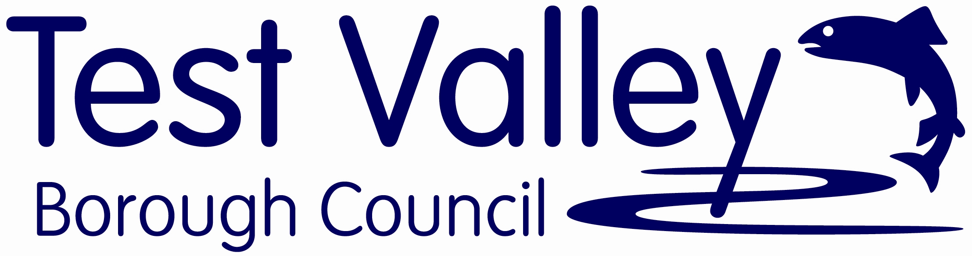
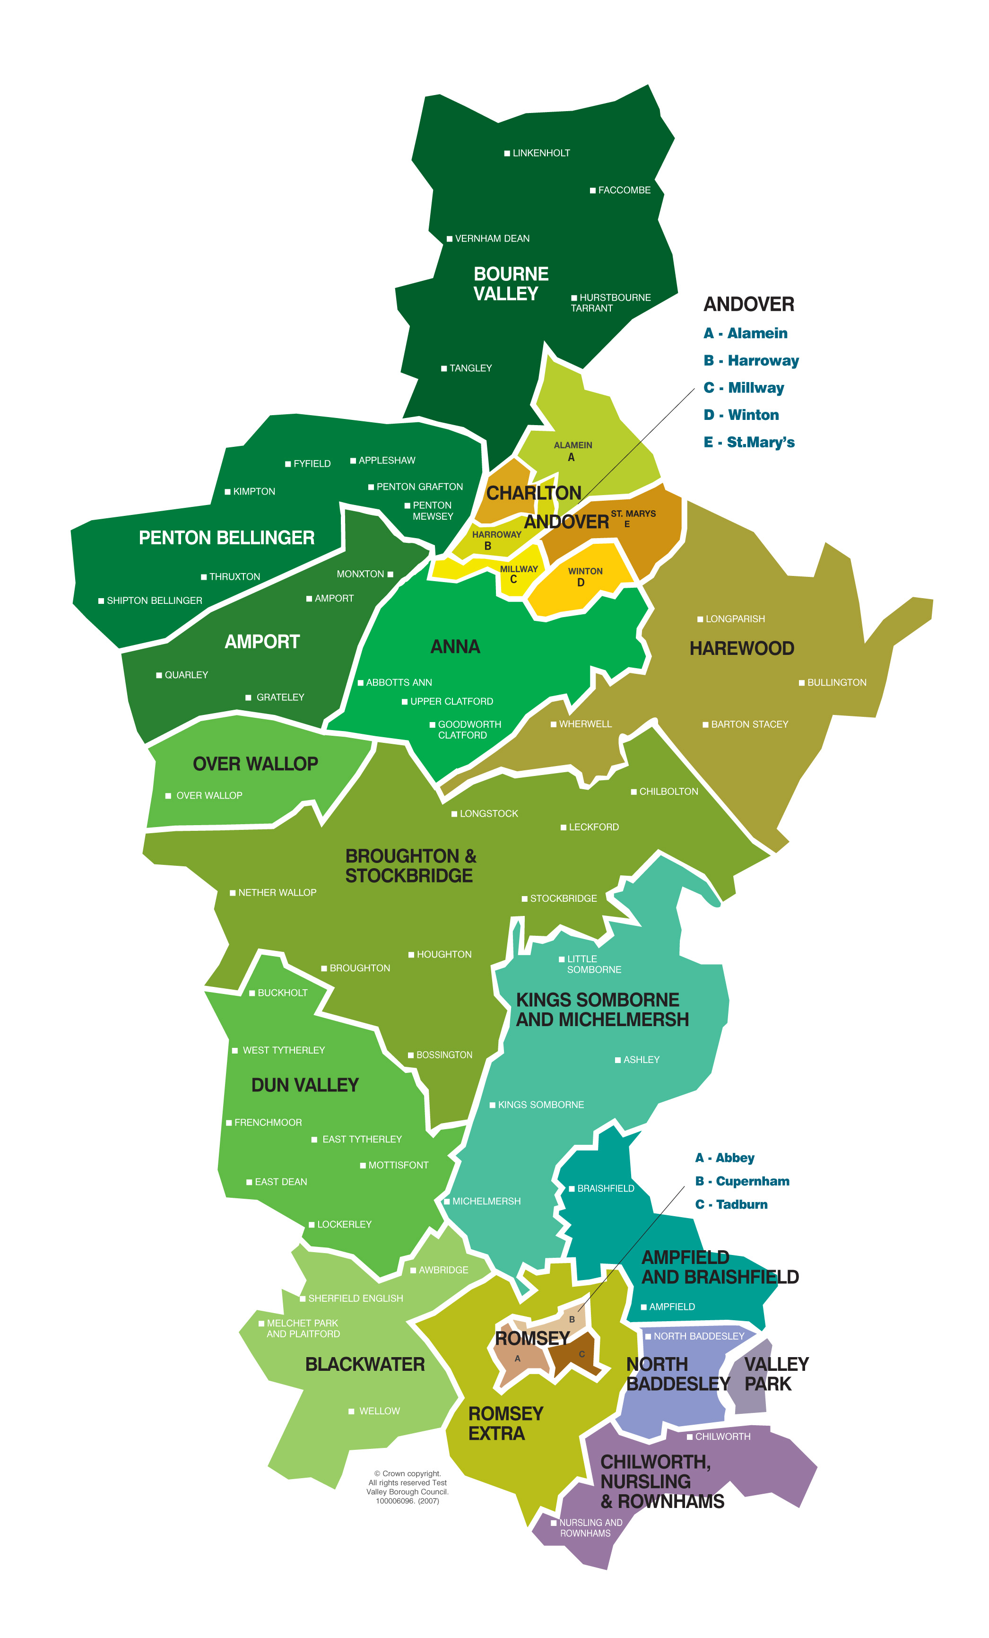

Equality information
Our duties under the Equality Act 2010
We are required to publish information that demonstrates our compliance with the Equality Duty as defined by the Equality Act 2010. This means that we have to show that we have had, in the exercise of our functions, due regard to the need to:
- eliminate discrimination, harassment and victimisation and any other conduct that is prohibited under the Act;
- advance equality of opportunity between people who share a relevant protected characteristic and people who do not share it;
- foster good relations between people who share a relevant protected characteristic and those who do not share it.
These are sometimes referred to as the three aims of the public sector equality duty.
Having due regard for advancing equality involves:
- removing or minimising disadvantages suffered by people due to their protected characteristics;
- taking steps to meet the needs of people from protected groups where these are different from the needs of other people;
- encouraging people from protected groups to participate in public life or in other activities where their participation is disproportionately low.
We have to demonstrate that we considered how the decisions we make and the services we deliver affect people who share different protected characteristics:
- age;
- disability;
- gender reassignment;
- sex (gender);
- sexual orientation;
- religion or belief (includes lack of belief);
- race;
- pregnancy and maternity;
- marriage and civil partnership.
There is no explicit legal requirement to collect and use equality information across all the protected characteristics, but in order to have due regard to the aims of the public sector equality duty, we must understand the impact of our policies and decision on people with different protected characteristics. Collecting and analysing equality information is an important way to develop this understanding.
We must publish relevant information by 31 January each year. We must include information about our employees and people affected by our policies and practices (for example, service users). The information should be accessible to the public and does not have to be published in a separate document.
Setting the scene in Test Valley
The Council is committed to ensuring equality of opportunity for all. As a service provider and an employer we are committed to ensuring fair treatment and equal access to our services, to information and to employment. This means that everyone can expect the same standards of treatment, regardless of their gender, disability, race, ethnic or national origin, age, religion or belief, or sexual orientation.
As a public body we will:
- ensure equality of opportunity for all;
- ensure fair treatment for everyone;
- ensure equal access to services, to information and to employment;
- eliminate unlawful discrimination on grounds of gender, disability, race, ethnic or national origin, age, religion or belief, or sexual orientation for our employees and for service users;
- promote good relations between different groups and individuals within our community;
- ensure quality services for everyone in the community.
Our commitment to equality and diversity is a key component of our Corporate Plan 2015- 2019: Investing in Test Valley. Our vision is to be an organisation of excellence committed to improving the quality of life of all the people in Test Valley. The vision is underpinned by our values, including Inclusiveness:
We value diversity, promote equality of opportunity for all and ensure that our services are accessible to everyone in Test Valley.
Inclusiveness is woven into the fabric of the Corporate Plan. Our communities told us what was important to them and we have developed our Plan accordingly, in order to respond to their most pressing concerns whilst ensuring that our plans concentrate on meeting the needs of individuals and groups in our communities. This document sets out some information in respect of local communities, service users and our staff.

A snapshot of diversity in Test Valley
Gender | According to forecasted data 51.7% of Test Valley residents are women and 48.3% are men.  27.1% of Test Valley Borough Councillors are women, and one of the eight (12.5%) Cabinet members is female.
Age – older | According to Hampshire Country Council Small Area Population Forecast for 2018:  22.5% of the Test Valley population is over 65.  - 54.7% of over 65s are women and 45.3% of over 65s are men.  - 65.1% of over 85s are women and 34.9% of over 85s are men. 1  These figures reflect wider trends that see women living longer. This has implications for services such as benefits, social services, leisure provision and transport for the older population.
Age – younger | - 18.6% of Test Valley residents are 15 years of age and under.  - 49.4% of those aged 15 and under are girls and 50.6% are boys.
Ethnicity | 92.6% of the population in Test Valley is White British, with 7.4% of the population from Black and Minority Ethnic backgrounds.  In January 2012, 11.2% of pupils in the Year R intake in all Test Valley schools were ethnic minority pupils (i.e. not White British).  72 different languages are spoken in Test Valley schools, and 4.7% of pupils have English as an additional language.
Gypsies and Travellers | Very little data is available regarding the number of Gypsies and Travellers in the borough at any one time. The latest EMTAS figures record less than 6 children from Gypsy Roma in Test Valley schools, and 12 children from families of Travelling Showpeople.  At the time of the 2011 Census, there were 153 people who identified as White Gypsies living in the borough.
Disability | In 2011, there were 2,047 people with a disability or long-term illness living in Test Valley.  Employment and Support Allowance (ESA) is a benefit for people who are unable to work due to illness or disability, and has replaced Incapacity Benefit. The number of residents receiving Employment Support Allowance or Incapacity Benefit was 2,614 in the May 2017 quarterly figures. Current statistics for the borough would not reflect disability wholly due to the introduction of Universal Credit in the South of the borough.  Personal Independence Payment (PIP) helps with some of the extra costs caused by long-term ill health or a disability, and started to replace Disability Living Allowance in April 2013. In Test Valley there were 1,940 PIP claims in October 2017.4
Religion | 67.8% of people living in Test Valley have a religious belief or faith, whilst 25.1% claimed to have no religion (7.1% of people declined to specify).  Of those who professed a religious belief, 96.9% said they were Christian.  0.6% of people with a religious faith are followers of Islam, the second largest religious group in Test Valley.
LGBT | There are no statistics available about the number of gay and lesbian residents in the borough. Stonewall estimates that there are 3.7 million lesbian, gay or bisexual people in the UK, which is 5.8% of the population.  The 2011 Census records 136 same-sex civil partnerships in the borough. On 17 July 2013 the government passed the Marriages (Same Sex Couples) Act, and the first same-sex marriages took place on 29 March 2014. Currently there is no data available which shows the number of same-sex marriages in the borough, but across England and Wales a total of 7,366 marriages were formed between same sex couples between 29 March 2014 and 30 June 2015. Of these, 55% (4,059 marriages) were between female couples and 45% (3,307 marriages) were between male couples.  Similarly, there are no reliable statistics for transgender people within Test Valley. A 2016 parliamentary report published by the House of Commons’ Women and Equalities Committee estimates that 650,000 people in the UK are ‘gender incongruent’, although statistical data regarding transgender people in the UK has been deemed far from ‘robust’.
Socio-economic | Most of the 24 wards within Test Valley are not considered to be deprived, according to the Indices of Multiple Deprivation 2015. However, Alamein ward has one area which is classified as suffering from deprivation and falls amongst the 20 per cent most deprived areas in England.  The number of residents (aged 16 to 64) receiving out-of-work benefits in Test Valley was 495 in December 2017, up from 425 in December 2016. This number is expected to be increasing due to the introduction of Universal Credit, under which a broader span of claimants are required to look for work.  2.5% of economically active people in Test Valley are unemployed, compared with 4.5% in Great Britain as a whole.9
English indices of deprivation 2015
In terms of levels of deprivation, Test Valley is ranked overall at 286 out of 326 local authorities in England (where the most deprived authority scores 1).
Only one lower layer super output area (LSOA) is ranked in the most deprived 20% in England - this is King Arthur's Way in Andover. 42 out of the 71 LSOAs in Test Valley are ranked in the lowest (least deprived) 20% of areas. Overall Test Valley remains in the least deprived 15% of local authorities in England, and overall residents in Test Valley are less likely to suffer deprivation than people living in other parts of England.
The factors which make up the indices are: income deprivation; employment deprivation; health deprivation and disability; education, skills and training deprivation; barriers to housing and services; crime; and living environment deprivation.
For comparison, district authorities in Hampshire are ranked overall as follows:

 | Rank (out of 326)
Hart | 326
Fareham | 312
Winchester | 307
East Hampshire | 308
Test Valley | 286
Eastleigh | 298
Basingstoke and Deane | 275
New Forest | 257
Rushmoor | 205
Gosport | 131
Havant | 142

Further information

For more information, please contact the Policy Team on policyteam@testvalley.gov.uk or 01264 368000.

Demographic profile for Test Valley produced by Hampshire County Council: http://www3.hants.gov.uk/2011_census_test_valley_summary_factsheet.pdf

Small area population forecasts can be found here, including population forecasts by wards and parishes:
http://www3.hants.gov.uk/factsandfigures/population-statistics/pop-estimates/small-area-pop-stats.htm

Ward profiles for each of Test Valley’s 24 wards contain demographic information about ward populations, and can be found on Test Valley Borough Council’s website:
http://www.testvalley.gov.uk

A range of information about ethnic minority and traveller children is available from the Ethnic Minority and Traveller Achievement Service (EMTAS):
http://www3.hants.gov.uk/education/emtas.htm

The Association of Public Health Observatories produces a health profile for each local authority area in England. The latest publication for Test Valley Borough Council is available here:
http://www.apho.org.uk/resource/view.aspx?RID=50215&SEARCH=T*

Nomis is a service provided by the Office for National Statistics (ONS) to give free access to the most detailed and up-to-date UK labour market statistics from official sources:
http://www.nomisweb.co.uk/
Test Valley’s profile can be found here:
https://www.nomisweb.co.uk/reports/lmp/la/1946157309/report.aspx

The Office for National Statistics collect, compile, analyse and disseminate of a range of economic, social and demographic statistics relating to the United Kingdom:
http://www.ons.gov.uk/ons/index.html

The Department for Work and Pensions (DWP) publish a range of statistics and reports that provide accurate and comprehensive information about DWP's client groups, benefits, employment programmes, estimates of households living in poverty and other areas that the Department is responsible for:
http://tabulation-tool.dwp.gov.uk/100pc/tabtool.html

The English Indices of Deprivation 2015 can be found here:
https://www.gov.uk/government/statistics/english-indices-of-deprivation-2015

All data is taken from the ONS 2011 Census unless otherwise stated. ? Hampshire Small Area Population Forecasts, accessed http://www3.hants.gov.uk/factsandfigures/population-statistics/pop-estimates/small-area-pop-stats.htm 2 EMTAS Spring Survey and Spring Traveller Questionnaire, Hampshire County Council, 2014. 3 Nomis Official Labour Market Statistics. Accessed 14/01/2016: http://www.nomisweb.co.uk/reports/imp/la/1946157309/subreports/dwp_time_series/report.aspx
5 http://www.ons.gov.uk/ons/rel/vsob1/marriages-in-england-and-wales--provisional-/for-same-sex-couples--2014/sty-for-same-sex-couples-2014.html)
6Report by Women and Equalities Committee, ‘Transgender Equality’. Accessed 14/01/2016: http://www.parliament.uk/business/committees/committees-a-z/commons-select/women-and-equalities-committee/news-parliament-2015/transgender-inquiry-report-published-15-16/
7The English Index of Multiple Deprivation (IMD) 2015. Accessed 12.01.2018: http://dclgapps.communities.gov.uk/imd/idmap.html
8Nomis, December 2016 – December 2017. Accessed 09.02.2018: https://www.nomisweb.co.uk/reports/imp/la/1946157309/subreports/cc_time_series/report.aspx?

